Logical Architecture & Use Cases

* XID: x00075734
* Name: Craig Hogan
* Project Title: TU Dublin Camp Booking System

## Logical Architecture

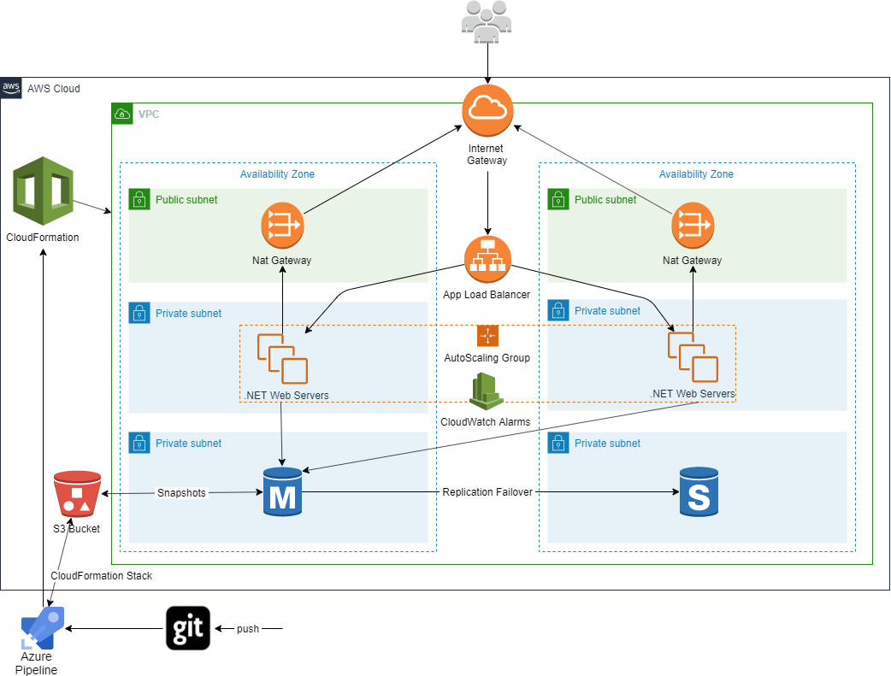

## Logical Architecture Discussion

* CI/CD Pipeline: I will implement a CI/CD pipeline using the specified project repository. This git repository will be linked to my Azure DevOps account where I will setup a pipeline to build/test and then deploy to AWS. I will store my pre-configured CloudFormation json stack in an S3 bucket, this stack will include all of the infrastructure needed to deploy my web application; VPC, subnets, IGW, Nat Gateways, Load Balancers and CloudWatch Alarms/Rules for auto-scaling etc. The pipeline will retrieve this CloudFormation stack from an S3 bucket and create/update the AWS infrastructure, build and test my web application and deploy it on this infrastructure. As the .NET web servers are in private subnets for security reasons, NAT Gateways will be used to allow the servers to connect to the internet/other services for updating or patching etc. without allowing incoming traffic.
* The AWS infrastructure will use 2 Availability Zones to remove a single point of failure. Traffic into the VPC will be through the Internet Gateway and will flow onto the application load balancer which will distribute traffic between the .NET web servers in both Availability Zones.
* Auto-scaling will be automated to deal with spikes in demand and to make sure resources are not wasted and .NET web servers are not being underutilized. This will be done using Launch Configurations, Auto Scaling Groups and CloudWatch rules and alarms. I will be using Amazon RDS to persist application data. Database snapshots will be stored in an S3 bucket and a multi availability zone database deployment will be used for high availability.

## Use Cases:

|  |  |
| --- | --- |
| Title | Upload student survey in .pdf format |
| Primary Actor | Admin/Lecturer |
| Story | Lecturers carry out thousands of paper written (has to be written as children under 18 need parents signature/permission) student surveys per year in order to carry out specific research and data analysis. Lecturers will be able to scan the surveys and upload them onto the system. The system will extract the required data from each survey which will be entered into the database. |

|  |  |
| --- | --- |
| Title (goal) | Upload government CSO .csv files |
| Primary Actor | Admin/Lecturer |
| Story | Live CSV files from the government CSO website will be used to gather information on every school in Ireland into the app database. Lecturers will be able to upload these CSV files on the admin panel (this will be needed as the CSV files are updated every few months). This information will facilitate the above pre-population of booking fields for schools and will also provide a wealth of information to lecturers such as school gender, school numbers, school location (LAT/LONG/X/Y). |

|  |  |
| --- | --- |
| Title (goal) | Get Google Maps directions to schools |
| Primary Actor | Admin/Lecturer |
| Story | As we will have location data for every school in Ireland, location information will be used to calculate time to travel to schools for lecturers/google map directions using the google maps API. |

|  |  |
| --- | --- |
| Title (goal) | Add available camp dates for schools to book |
| Primary Actor | Admin/Lecturer |
| Story | As administrators, each lecturer can add dates/time slots which they are available for school camps. These dates will then be available for schools to make camp bookings. Once a school books a specific camp slot for a lecturer, this slot will no longer be available for other schools to book |

|  |  |
| --- | --- |
| Title (goal) | View list of booking |
| Primary Actor | Admin/Lecturer |
| Story | Lecturers can login and view a list of school camp bookings via the admin panel. Each school booking will contain information such as school name, camp date, county, phone number, email, camp lecturer. Extra information (school gender, school numbers, school location; county, Eircode etc.) will be available to lecturers by entering a specific school booking. |

|  |  |
| --- | --- |
| Title (goal) | Search the list of camp bookings |
| Primary Actor | Admin/Lecturer |
| Story | Lecturers can search the list of school camp bookings by either school name, school county or camp lecturer to retrieve specific school bookings |

|  |  |
| --- | --- |
| Title (goal) | Edit/Close school bookings |
| Primary Actor | Admin/Lecturer |
| Story | Lecturers can login and edit or close (completed) school bookings via the admin panel |

|  |  |
| --- | --- |
| Title (goal) | Make camp booking |
| Primary Actor | School |
| Story | Schools can view a list of available slots for camps and make bookings on these dates. The booking process will be made as simple as possible for schools; once the school enters in their unique school roll number, the rest of the school’s information will be filled out automatically i.e. school name, address, Eircode, phone number, email etc. The school will be asked for additional information such as start and end time for camp, class groups (6th class, 4th year etc.), topics to be covered (choose from a list created on admin side), and also if they would like to opt-in to take part into surveys. |